**Assignment -1**

|  |  |
| --- | --- |
| Assignment Date | 15 September 2022 |
| Student Name | R Brindha |
| Student Roll Number | 812419106014 |
| Maximum Marks | 2 Marks |

**Question**

**Build a smart home in Tinker cad use at least 2 sensors ,led,buzzer in a circuit simulate in a single code**

**Circuit:**

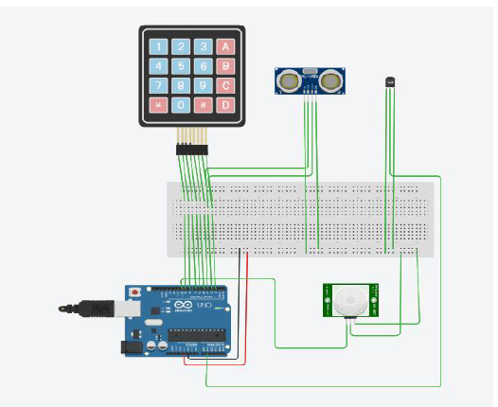

**Code:**

#include

//Keypad is used as lock pin

//Temperature is used it to maintain room temperature

//PIR sensor is used to alert movement at

//ultrasonic sensor is used to alert if dustbin is full

const byte ROWS = 4;

const byte COLS = 4;

int size = 0;

char hexaKeys[ROWS][COLS] = {

{'1', '2', '3', 'A'},

{'4', '5', '6', 'B'},

{'7', '8', '9', 'C'},

{'*', '0', '#', 'D'}

};

float Celsius, Fahrenheit, Kelvin;

byte rowPins[ROWS] = {9, 8, 7, 6};

byte colPins[COLS] = {5, 4, 3, 2};

Keypad customKeypad = Keypad(makeKeymap(hexaKeys), rowPins, colPins, ROWS, COLS);

void setup(){

pinMode(3, OUTPUT); // Sets the trigPin as an OUTPUT

pinMode(2, INPUT);

Serial.begin(9600);

}

void GetTemp()

{

int sensorValue = analogRead(A1);

Kelvin = (((float(sensorValue) / 1023) * 5) * 100);

Celsius = Kelvin-50;

Fahrenheit = (Celsius * 1.8) +32;

}

void loop(){

int passkey[4]={0,0,0,0},ans[4]={7,4,1,2},identity[4]={1,1,1,1};

char customKey = customKeypad.getKey();

if (customKey){

Serial.println(customKey);

Serial.println(ans[size]);

if(customKey == ans[size]){

Serial.println(size);

passkey[size]=1;

}

Serial.println(passkey[size]);

size++;

}

GetTemp();

Serial.print("Celsius: ");

Serial.println(Celsius);

Serial.print("Fahrenheit: ");

Serial.println(Fahrenheit);

Serial.println();

digitalWrite(3, LOW);

delayMicroseconds(2);

// Sets the trigPin HIGH (ACTIVE) for 10 microseconds

digitalWrite(3, HIGH);

delayMicroseconds(10);

digitalWrite(3, LOW);

// Reads the echoPin, returns the sound wave travel time in microseconds

long duration = pulseIn(2, HIGH);

// Calculating the distance

int distance = duration * 0.034 / 2; // Speed of sound wave divided by 2 (go and back)

// Displays the distance on the Serial Monitor

Serial.print("Distance: ");

Serial.print(distance);

Serial.println(" cm");

}